Dear Parent,

We are delighted that you child has chosen to attend our after school Lego club. The club is paid for in advance, on a half termly basis. It appears that you have missed the opportunity to pay for the club so far.

There are 2 ways to pay for the club:

1.Visit www.kidswithbricks.com and press ‘Book A Club’. Just follow the very obvious links to find your school and pay for your child’s place.
2.Fill out and return the slip below with a cheque attached.
Thank You

The Kids With Bricks Team

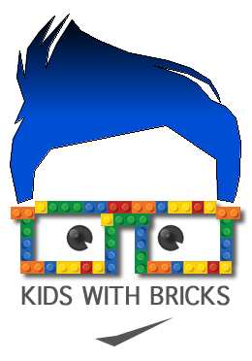
……………………………………….………..reply slip……………………………………………………..

4 weeks - 15.99
5 weeks - 19.99
6 weeks - 23.99
7 weeks - 27.99
Attached is a cheque for ............. covering the ......... weeks my child attended Minecraft Club

Parents name:………………………………………….

Childs name:................................................ School:……………………………………………………..

Year Group:…………….Tel:…………………………….. Email:...........................................................

Cheques can be made payable to Kids With Bricks Ltd
Please post reply slips to: Kids With Bricks, Merlin House, Langstone Business Park, Newport, NP18 2HJ

